Name
– Junior
– Comp Sci-BS
– Expected Grad. Date Fall 23 or if missing classes then Spring 24
Current – Fall 22
Class | Skills | Credit Hours
ITSC 2600 | Introduces the computer science program and develops a student's identity and career preparedness. | 2
ITSC 1213 | Advanced topics in Java including version control, use of debuggers, class design, aggregation and association, exception handling, generic and abstract types, inheritance, polymorphism, interfaces, and abstract classes. | 4
Total Credit Hours: |  | 6

Spring 23
Class | Skills | Credit Hours
ITSC 2214 | A study of the theory and implementation of abstract data types (ADTs) including stacks, queues, and both general purpose and specialized trees and graphs. | 3
ITSC 2175 | A study of discreet mathematical concepts. Introduction to propositional calculus, predicate calculus, algorithms, logic functions, finite-state machines; and logic design. | 3
? | ? | ?
MATH 1241 | Designed for students majoring in Mathematics, Science, or Engineering. Elementary functions, derivatives and their applications, introduction to definite integrals. | 3
Total Credit Hours: |  | 9 + ?

SUMMER 23
Class | Offered | Credit Hours
ITSC 3146 |  | 3
MATH 1242 |  | 3
MATH 2164 |  | 3
ITSC 3181 |  | 4
ITSC 3155 |  | 3
Total Credit Hours: |  | 9 + ?
Notes: Need to be a 3 or 4 credit class

FALL 23
Class | Offered | Credit Hours
STAT 2122 |  | 3
ITSC 3155 |  | 3
ITCS 3153 |  | 3
ITCS 4232/4238/4155 |  | 3
ITSC 2181
Total Credit Hours: |  | 12 +?
Notes: Need 8 credits. Graduate if Possible else Spring 24

Spring 24
Class | Offered | Credit Hours
?? |  | 3
?? |  | 4
Total Credit Hours: |  | 7
Notes: Only if not enough credit due to missing classes for SUMMER 23 and FALL 23.

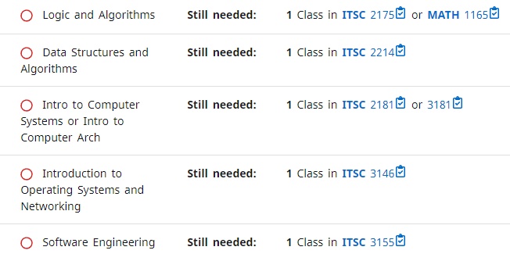
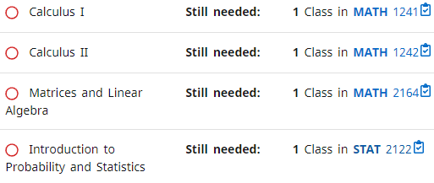
ITCS 4111
ITCS 3120
ITCS 4123
ITCS 4124
ITCS 4150
ITCS 4151
ITCS 4152
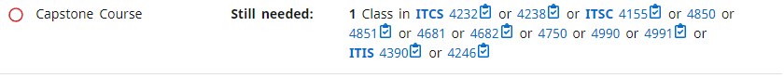
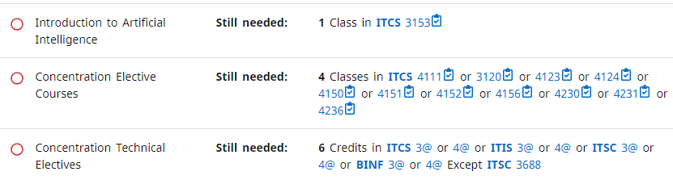
https://catalog.charlotte.edu/preview_program.php?catoid=32&poid=8543

